**VJTI Website**

Member 1: Jainam C Shah

Member 2: Aman Framewala

Member 3: Yash Dani

Member 4: Ansh Bilimoria

Duration of Project: 9/5/2017- 17/7/2017

**VJTI Website**

# Abstract

We wanted to give the VJTI website a better look and user interface.

**Completion status**

The website has been made with 7 working pages with a good user interface.

# Softwares used

* Notepad++
* Sublime text
* Xampp
* PHPmyadmin
* MySQL Workbench

# Software and Code

Github link(Without Database):<https://github.com/ABCF98/VJTI-WEBPAGE>

# Use and Demo:

# C:\Users\jcsha\Pictures\Screenshots\Screenshot (173).png

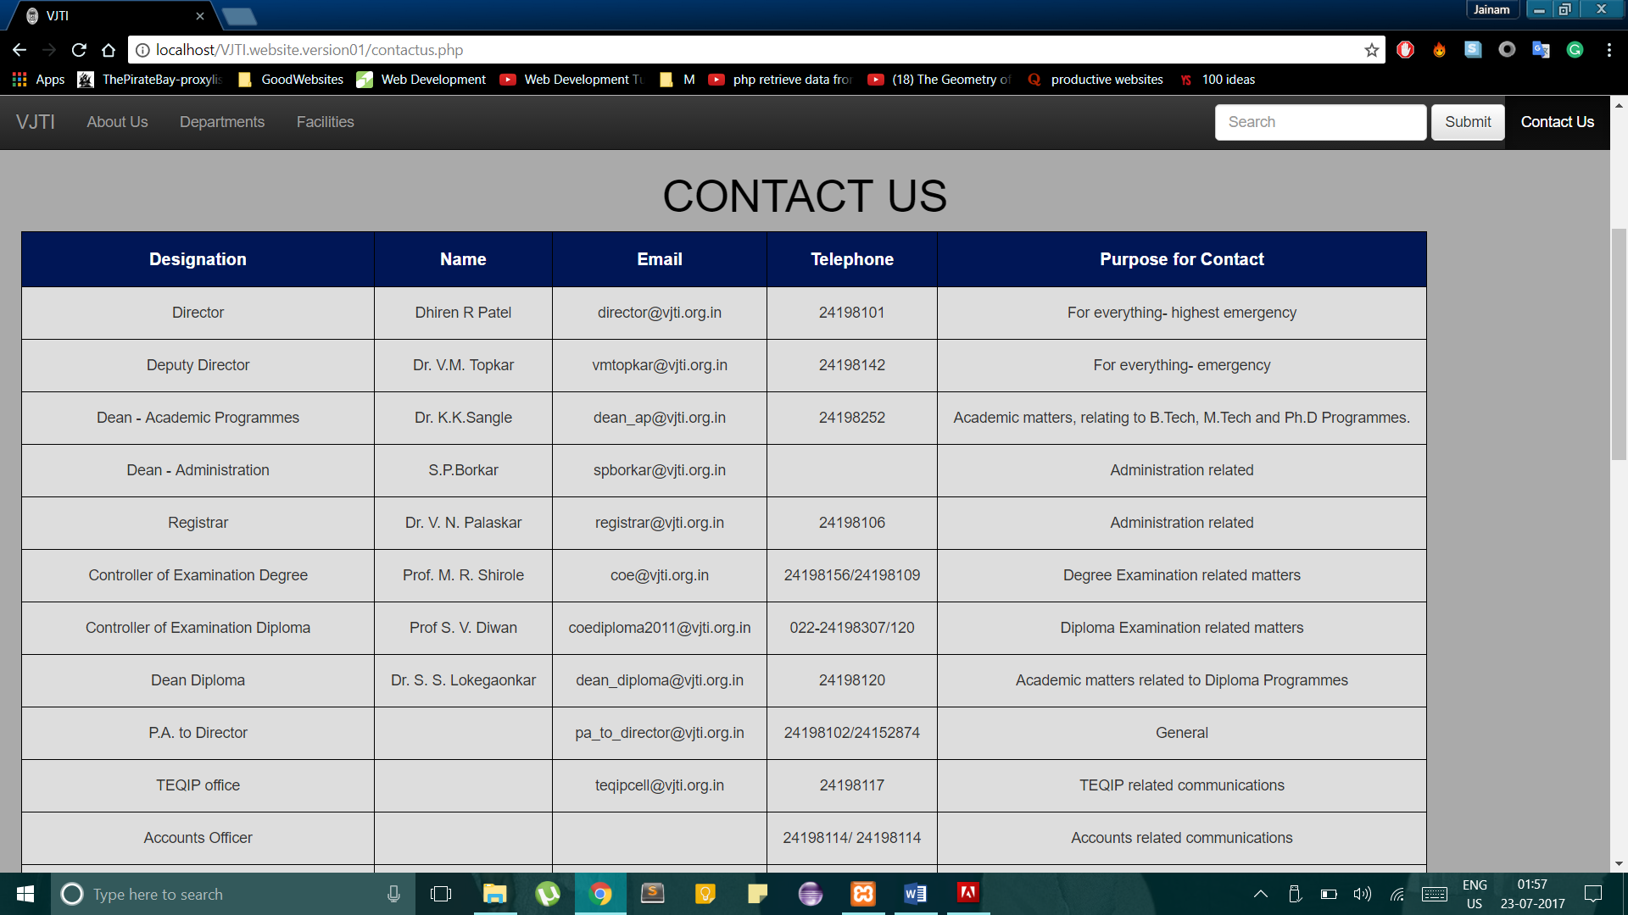

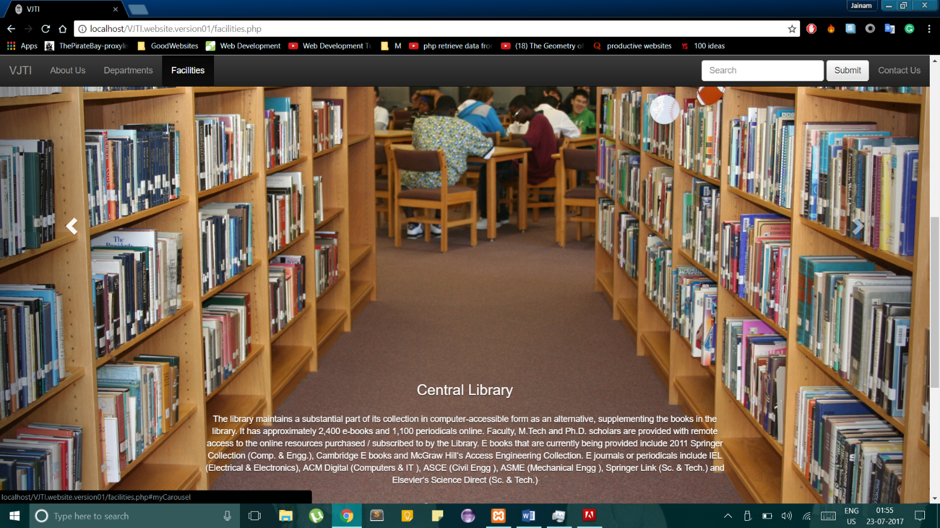

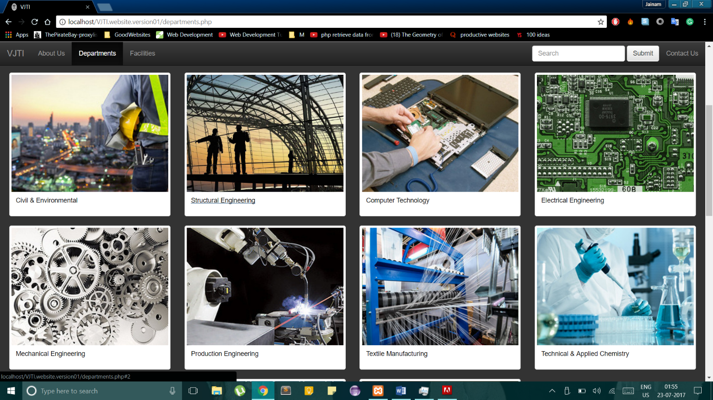



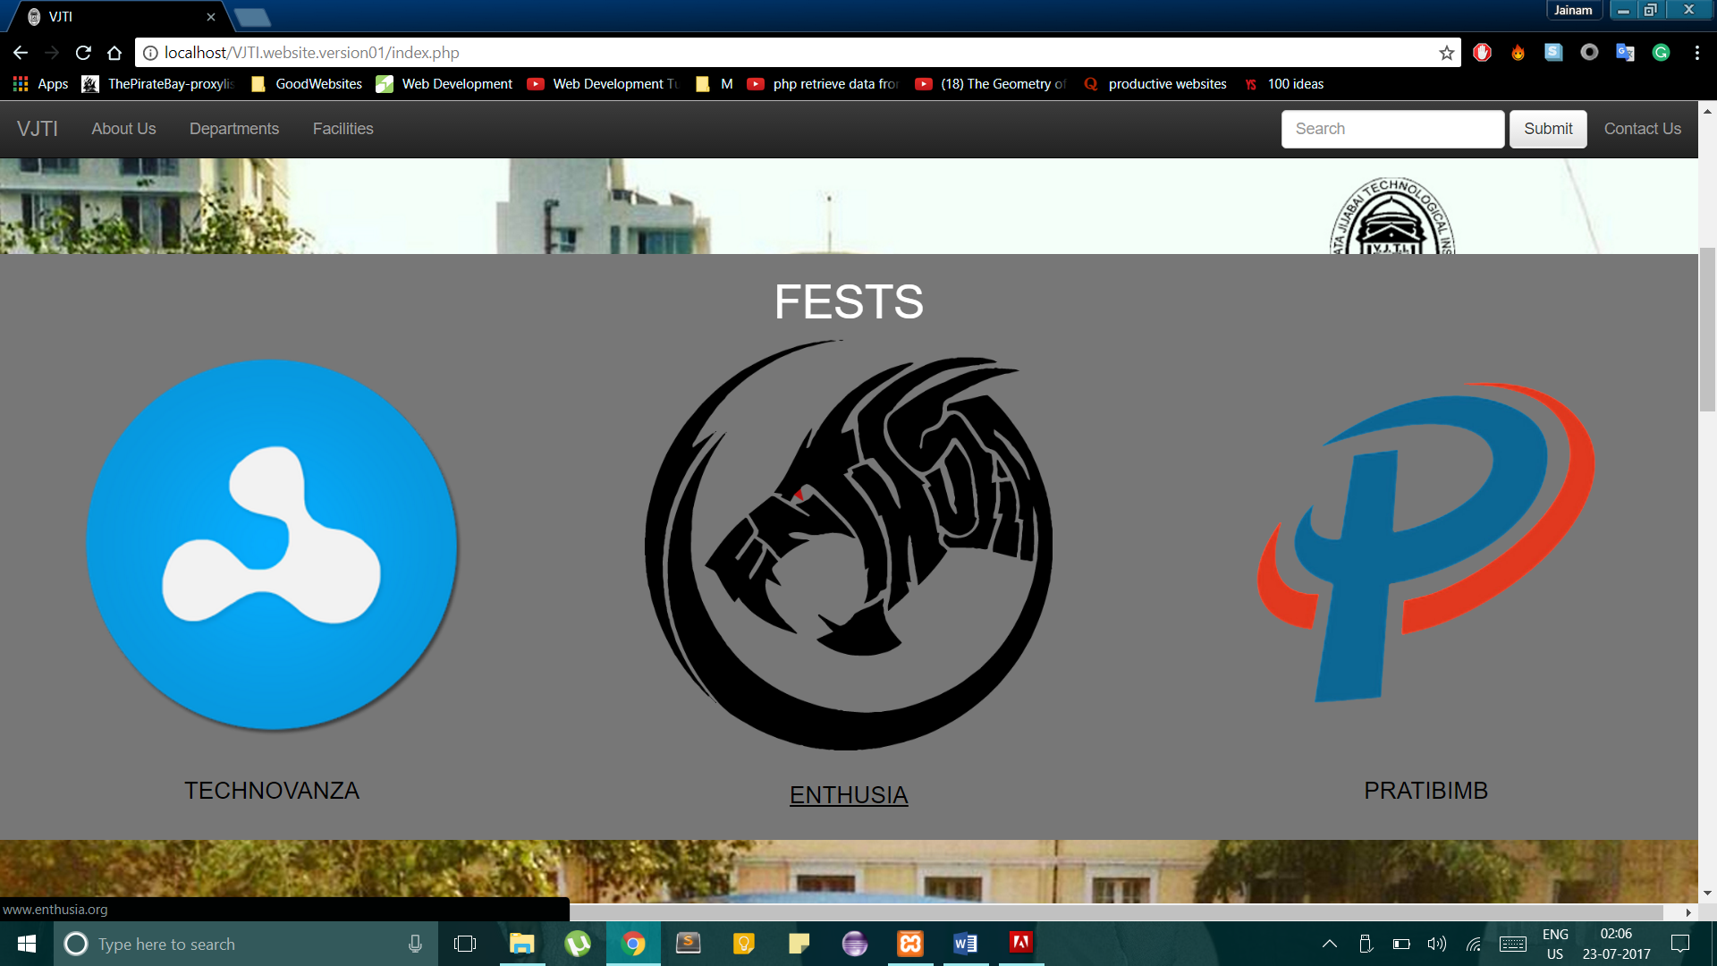

# Future Work

Login ID for students and faculty can be added.

An interactive syllabus for all years including reference book suggestions.

Discussion forum for students to discuss the problems they are facing and tips for the future.

Notifications for assignment submission dates and other things like Facebook in Google chrome.

# Bug report and Challenges

It was a bit difficult to make the website considering we had absolutely no prior knowledge about anything in web development or any of the languages.

Retrieving the data from the databases was difficult.

Finding errors in CSS was difficult.